**InsightStream: Navigate the News Landscape**

**Ideation Phase**

**Define the Problem Statements**

| Date | 7 march 2025 |
| --- | --- |
| Team ID | SWT1D1741164806148446 |
| Project Name | InsightStream |
| Maximum Marks | 2 Marks |

**Problem Statement:**

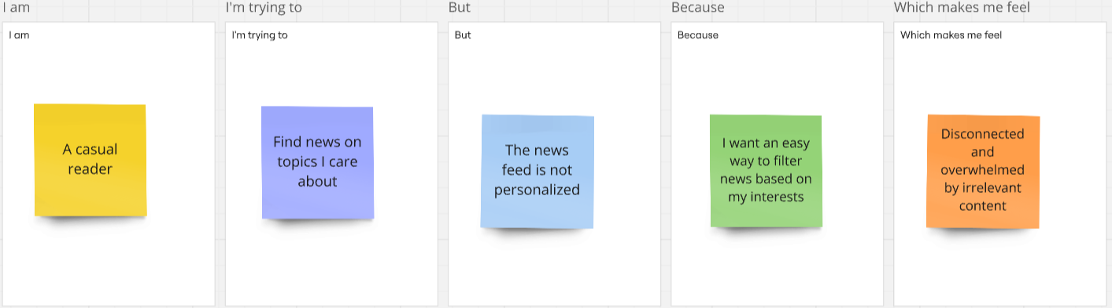

| Problem Statement (PS) | I am (Customer) | I’m trying to | But | Because | Which makes me feel |
| --- | --- | --- | --- | --- | --- |
| PS-1 | A busy professional | Stay updated with the latest news quickly | Most news websites are cluttered with ads and unnecessary content | I need a clean, distraction-free interface with only relevant news | Frustrated and unwilling to browse for long |
| PS-2 | A casual reader | Find news on topics I care about | The news feed is not personalized | I want an easy way to filter news based on my interests | Disconnected and overwhelmed by irrelevant content |
| PS-3 | A mobile user | Read news on the go | Many platforms are not mobile-friendly or take too long to load | I need a smooth, fast-loading, and responsive experience | Annoyed and likely to leave the platform |
| PS-4 | A user concerned about credibility | Get reliable news from trusted sources | A lot of platforms spread misinformation or lack source transparency | I need verified news from reputable sources | Skeptical and unsure which news to trust |